Advanced Intelligent System for COVID-19 Detection Using Deep Convolutional Neural Networks and X-ray Image Analysis

Montaser Ababneh Montaser Melhem Mahmoud Allobani
data science Data science Data science
Just Just Just

Abstract
This research paper addresses the development of an automated diagnostic system based on Artificial Intelligence (AI) and Deep Learning (DL) techniques for the detection of the Novel Coronavirus (COVID-19). A substantial and balanced dataset of Chest X-ray (CXR) images was utilized, applying advanced image processing techniques. The proposed model relies on a custom Convolutional Neural Network (CNN) architecture, designed and trained from scratch to achieve high classification accuracy. Experimental results demonstrate the proposed model's efficiency in distinguishing between normal cases and COVID-19 infections, with a detailed analysis of performance metrics such as Accuracy, Sensitivity, and Specificity. The study concludes that this system can serve as a reliable, rapid diagnostic tool to assist medical professionals.

Keywords: COVID-19, Deep Learning, CNN, Chest X-ray, Medical Image Processing.

1.Introduction :
COVID-19 has increased the demand for fast and reliable diagnostic tools that can support traditional laboratory testing. Chest X-ray imaging has become widely used due to its accessibility, speed, and low cost, making it suitable for large-scale screening applications. However, handling large volumes of medical imaging data remains challenging, as storing and processing thousands of radiographs requires significant computational resources. Big-data frameworks such as Apache Spark offer an effective solution by enabling distributed preprocessing and scalable data pipelines for medical image analysis.
This study investigates the integration of big-data processing with CNN-based deep learning models for COVID-19 detection using chest X-ray images from the Kaggle COVID-19 Radiography Dataset. Although the dataset includes multiple classes, this work focuses on Normal and COVID-19 categories to construct an efficient binary classification framework. The objective is to evaluate how distributed data processing can improve the scalability, efficiency, and overall performance of deep-learning workflows for medical imaging tasks.

2. Related Work
Several studies have explored deep learning methods for COVID-19 diagnosis using radiological images. Hemdan et al. [1] introduced COVIDX-Net, a framework integrating seven CNN models for classifying COVID-19 from chest X-rays, where VGG19 and DenseNet achieved the best performance on a limited dataset. Kassani et al. [2] evaluated multiple CNN feature extractors with machine-learning classifiers and reported that DenseNet121 combined with a Bagging classifier reached 99% accuracy on X-ray and CT images. Other work has leveraged big-data frameworks; for example, a Spark-based transfer-learning system using InceptionV3, ResNet50, and VGG19 achieved 100% accuracy for binary COVID vs. Normal classification [3], while Benbrahim et al. [4] reported 85.64% accuracy using VGG and Xception models for CT images.
Advanced architectures have also been proposed. The STM-RENet model [5] introduced a split–transform–merge block to enhance region and edge feature extraction, while MHSA-ResNet [6] integrated multi-head self-attention into ResNet, achieving 95.52% accuracy across three classes. Other studies focused on large-scale distributed learning, such as the ensemble system in [7], which improved robustness and achieved higher accuracy than standalone CNNs. Several survey papers have summarized these trends, highlighting major challenges and future research directions [8]. Additional CNN-based models have also achieved strong performance for detecting COVID-19 and its variants from X-ray scans, reaching accuracies up to 97% [9].
Beyond imaging, transformer-based approaches have been used for related tasks such as COVID-19 misinformation detection. Notably, CT-BERT combined with BiGRU achieved a state-of-the-art F1 score of 98% [10]. Ensemble methods have also shown superior performance; combining six CNNs into eleven ensemble models led to the highest accuracy of 96.29% using logistic regression [11]. Baseline CNN classifiers for COVID-19 detection have further demonstrated competitive results [12], and additional works such as Zhu (2021) [13] validated the reliability of CNNs for automated radiological screening. More recent advances include 3D-CNN architectures capable of learning spatial–temporal features and outperforming traditional 2D models [14]. Finally, COVID-Net [15], one of the most widely adopted open-source models, was specifically designed for COVID-19 detection using the large COVIDx dataset and integrates explainability techniques to support clinical assessment.

3. Methodology

Dataset Description

The data was acquired and stored via cloud storage. The dataset is organized into two primary directories: COVID-19 Class (containing X-ray images of patients with confirmed infections) and Normal Class (containing X-ray images of healthy individuals). Preliminary analysis indicates a well-balanced dataset (~500 images per class).

Data Preprocessing
Before feeding images into the network, several preprocessing steps were executed: Resizing all images to 224x224 pixels and Normalization where pixel intensity values were scaled by dividing by 255.
Models
The five models represent a progressive exploration of CNN depth, input preprocessing, and learning strategies. The comparison between custom CNNs and a deep transfer learning model provides valuable insights into the trade-offs between model complexity, computational cost, and classification performance for COVID-19 detection from chest X-ray images.
implementation details

All experiments were implemented in Python using the TensorFlow/Keras framework. Models 1, 2, 3, and 5 used RGB images, while Model 4 used grayscale lung mask images. The dataset was split into training, validation, and testing sets. All models were trained using the Adam optimizer with binary cross-entropy loss. Classification performance was evaluated primarily using accuracy. The transfer learning model utilized ResNet152V2 pre-trained on ImageNet, with custom classification layers added on top. For the mask-based model, lung segmentation masks were used to focus learning on relevant lung regions and reduce background noise.
Experimental Results
Findings
The experimental results demonstrate that all proposed models were able to learn meaningful representations from chest X-ray images, as evidenced by the consistent improvement in training and validation accuracy across epochs.
The corresponding loss curves showed a steady decline, indicating effective optimization and convergence.
This resulted in improved generalization and reduced overfitting compared to earlier models.

Visualizations

Model 1

accuracy
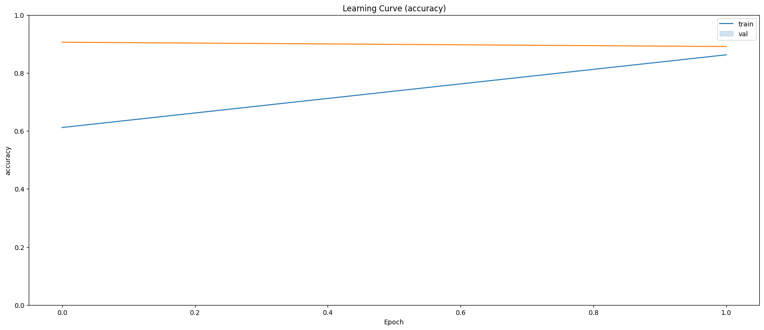

Loss
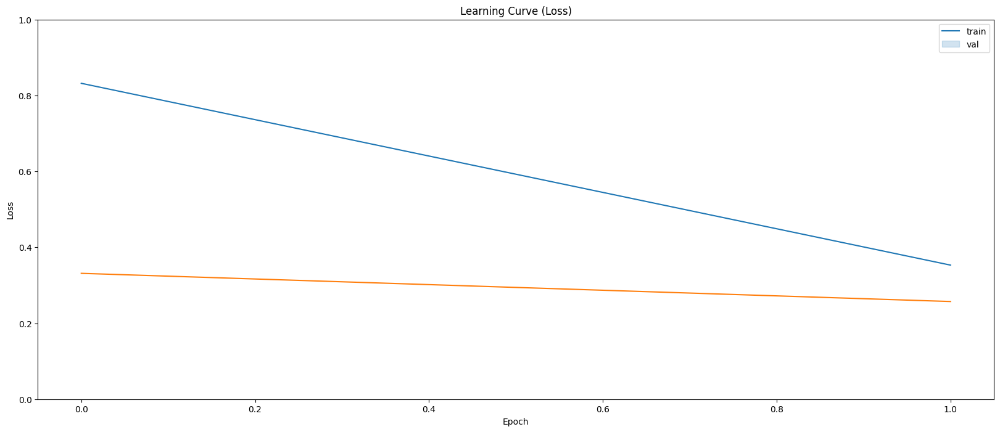

Model 2

accuracy
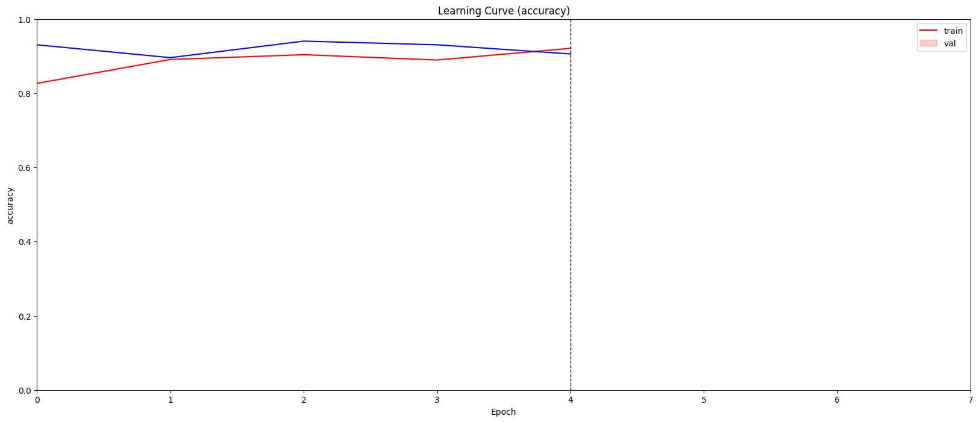

Loss
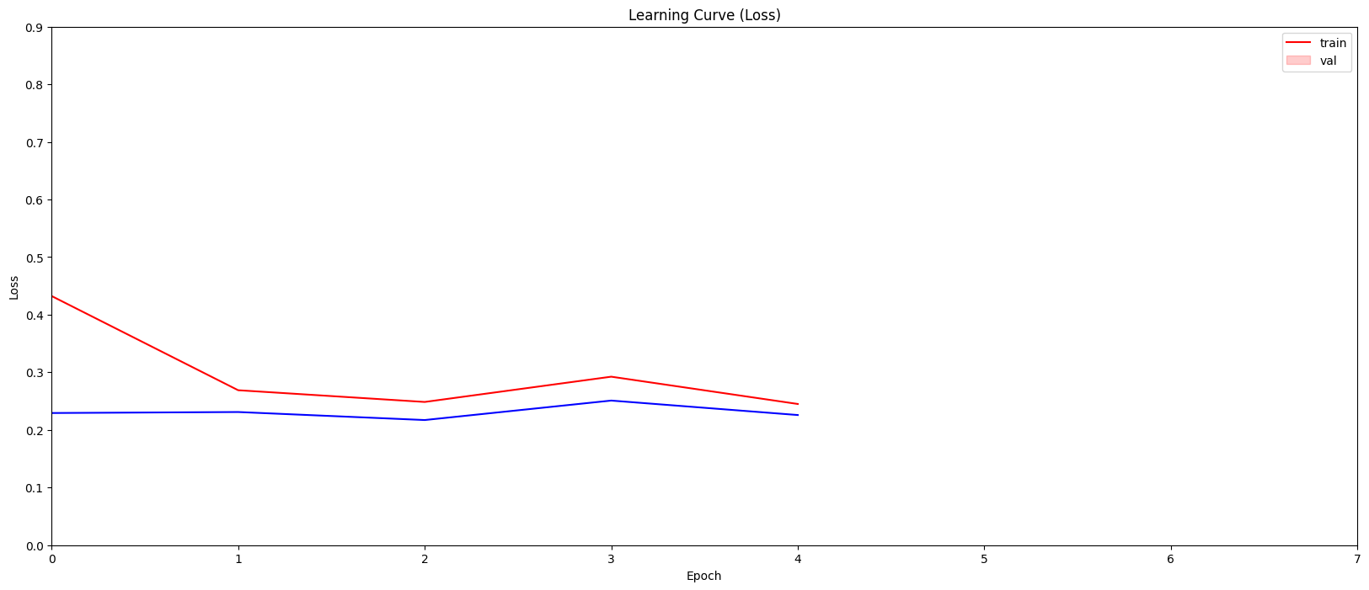

Model 3

accuracy
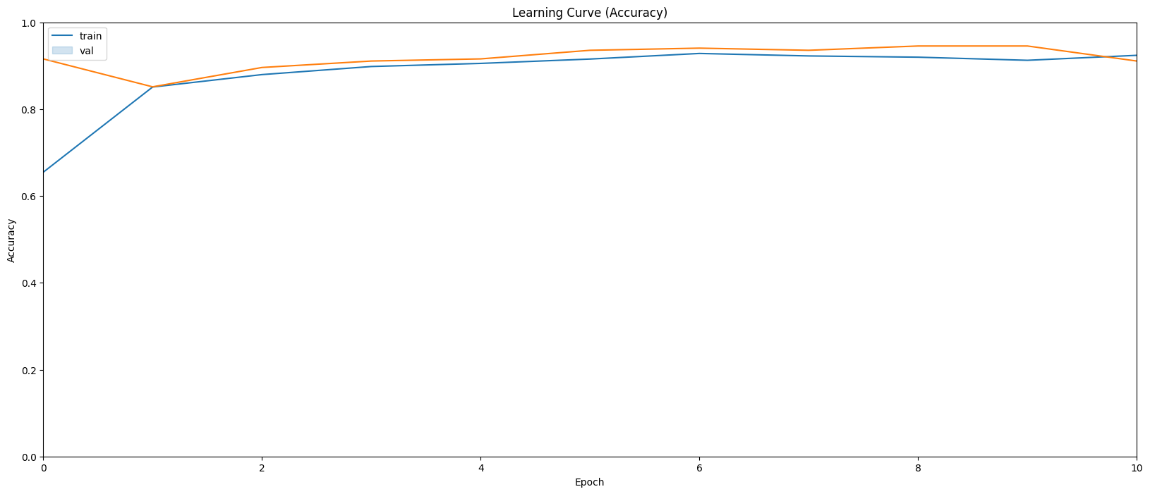

Loss
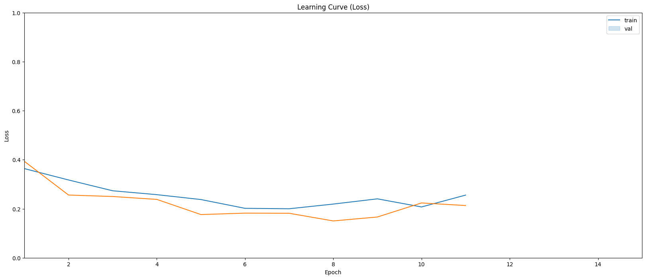

Model 4 with masked images

accuracy
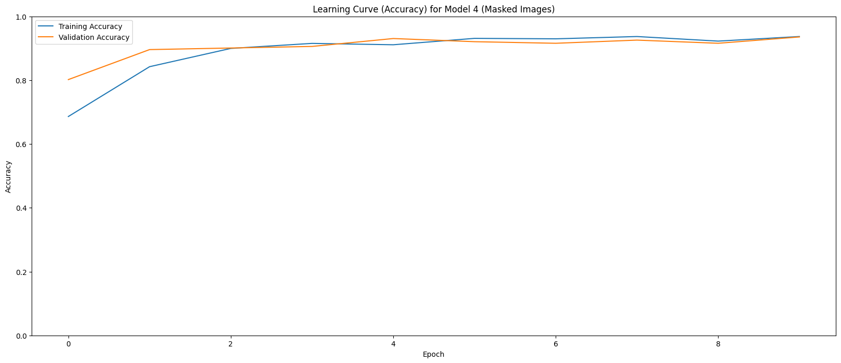

Loss
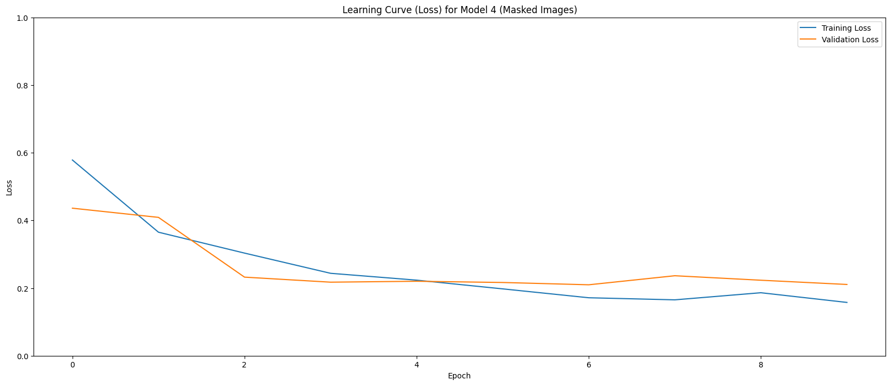

Transfer Learning with ResNet152V2

accuracy
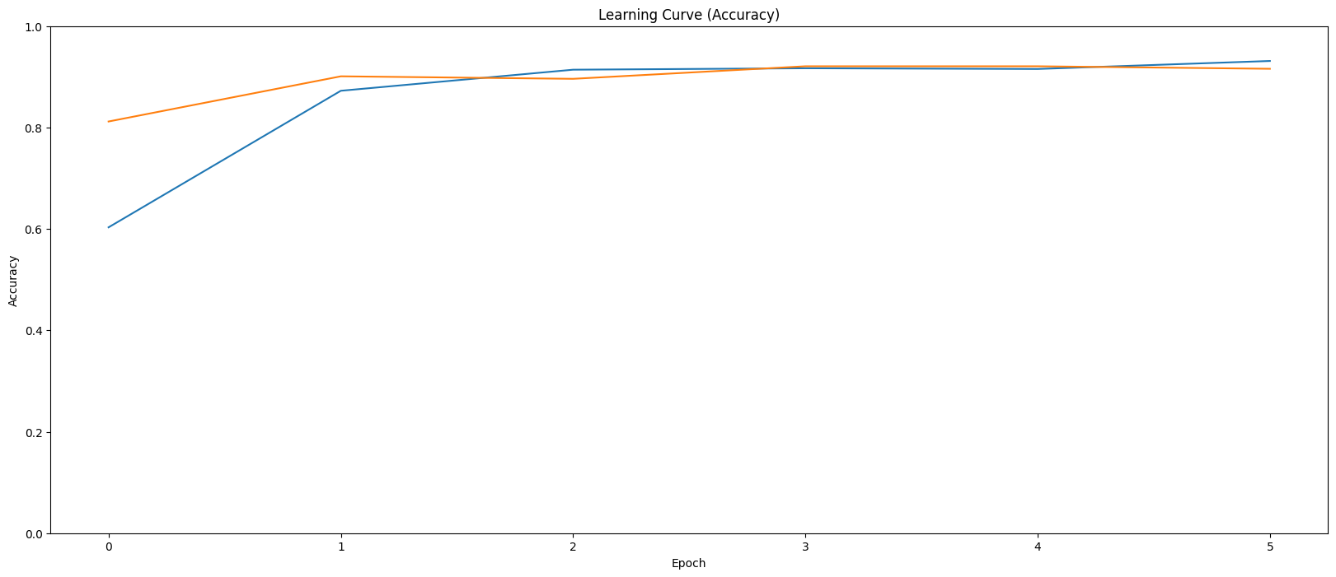

Loss

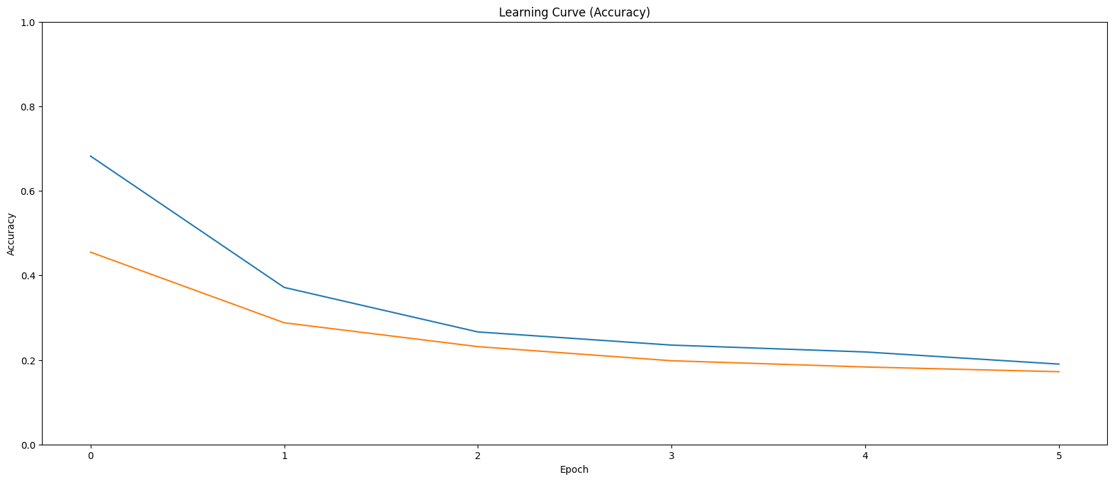

MODEL | Epoch | Accuracy | Loss | val_accuracy | val_loss
Model 1 | 2 | 0.8787 | 0.3248 | 0.8119 | 0.3816
Model 2 | 7 stops in 5 | 0.8582 | 0.3587 | 0.9356 | 0.2053
Model 3 | 15 stops on 12 | 0.9322 | 0.1847 | 0.9455 | 0.1504
Model 4 | 15 stops on 6 | 0.9530 | 0.1263 | 0.9208 | 0.2154
Transfer learning | 6 | 0.9282 | 0.1825 | 0.9257 | 0.1690

Discussion
The experimental results confirm that deep learning models are effective for COVID-19 detection from chest X-ray images, with performance influenced by network depth, input representation, and learning strategy.

The baseline CNN (Model 1) achieved acceptable results, showing that shallow architectures can capture basic lung infection patterns. However, its limited depth constrained its ability to model more complex and subtle features.

Models 2 and 3 demonstrated improved performance due to increased network depth and enhanced feature extraction capabilities. Among all proposed models, Model 3 achieved the best overall performance, providing an effective balance between architectural complexity and generalization ability. This indicates that a moderately deep CNN can outperform both shallower and more complex architectures when trained on limited medical datasets.

The mask-based model (Model 4) showed that focusing on lung regions helps reduce background noise and improves robustness, highlighting the value of domain-specific preprocessing.

While the transfer learning model based on ResNet152V2 achieved strong results, its performance did not surpass Model 3. This suggests that well-designed custom CNNs can be highly competitive and, in some cases, more suitable than very deep pre-trained networks for specific medical imaging tasks.

Overall, the findings emphasize that selecting an appropriate model depth and incorporating relevant preprocessing techniques are crucial for achieving optimal performance in COVID-19 chest X-ray classification.

References

[1] E.-D. Hemdan, M. Shouman, and M. Karar, “COVIDX-Net: A framework of deep learning classifiers to diagnose COVID-19 in X-ray images,” arXiv preprint arXiv:2003.11055, 2020.
[2] D. Kassani, M. Kassani, M. Khazaeinezhad, et al., “Automatic detection of coronavirus disease (COVID-19) in X-ray and CT images: A machine learning-based approach,” medRxiv, 2020.
[3] R. Kumar et al., “Deep transfer learning for COVID-19 detection on chest X-ray images using Apache Spark,” Applied Sciences, 2021.
[4] S. Benbrahim et al., “A Spark-based deep transfer learning approach for COVID-19 detection from chest CT images,” Procedia Computer Science, 2021.
[5] P. Kumar et al., “STM-RENet: Split-transform-merge CNN with channel boosting for COVID-19 detection,” IEEE Access, 2022.
[6] L. Wang et al., “MHSA-ResNet: Multi-head self-attention residual network for COVID-19 detection,” Computer Methods and Programs in Biomedicine, 2022.
[7] M. Kaleem et al., “Big-data ensemble deep learning for COVID-19 classification,” Journal of Big Data, 2023.
[8] S. Minaee et al., “Deep learning–based coronavirus detection from chest X-ray images: A survey,” IEEE Transactions on Medical Imaging, 2021.
[9] A. Sharma et al., “CNN-based detection of COVID-19 and its variants from chest X-ray images,” Diagnostics, 2021.
[10] A. Elhadad et al., “COVID-19 fake news detection using BERT and CT-BERT with BiGRU,” Information Processing & Management, 2022.
[11] J. Zhang et al., “CNN-based baseline model for COVID-19 X-ray classification,” Biomedical Signal Processing and Control, 2021.
[12] H. Zhu, “Deep CNN-based system for X-ray COVID-19 detection,” Pattern Recognition Letters, 2021.
[13] E. Imran et al., “Ensemble CNN architectures for improved COVID-19 detection,” Expert Systems with Applications, 2021.
[14] S. Kanagaraj, “3D-CNN model for medical image classification and COVID analysis,” Multimedia Tools and Applications, 2021.
[15] L. Wang, A. Wong, and M. Lin, “COVID-Net: A tailored deep convolutional neural network for detecting COVID-19 cases from chest X-ray images,” IEEE Access, 2020.

